

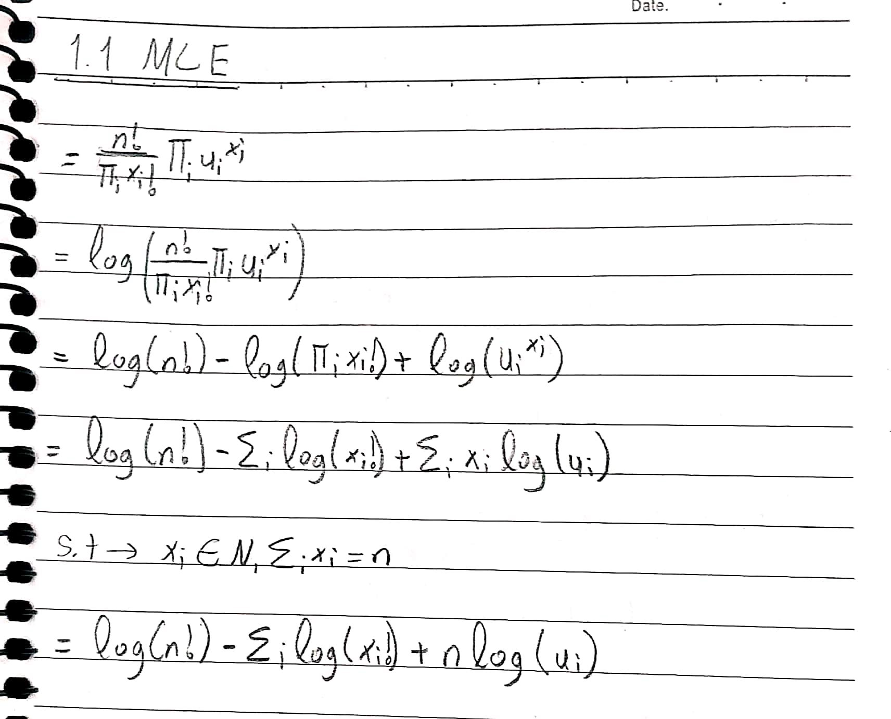

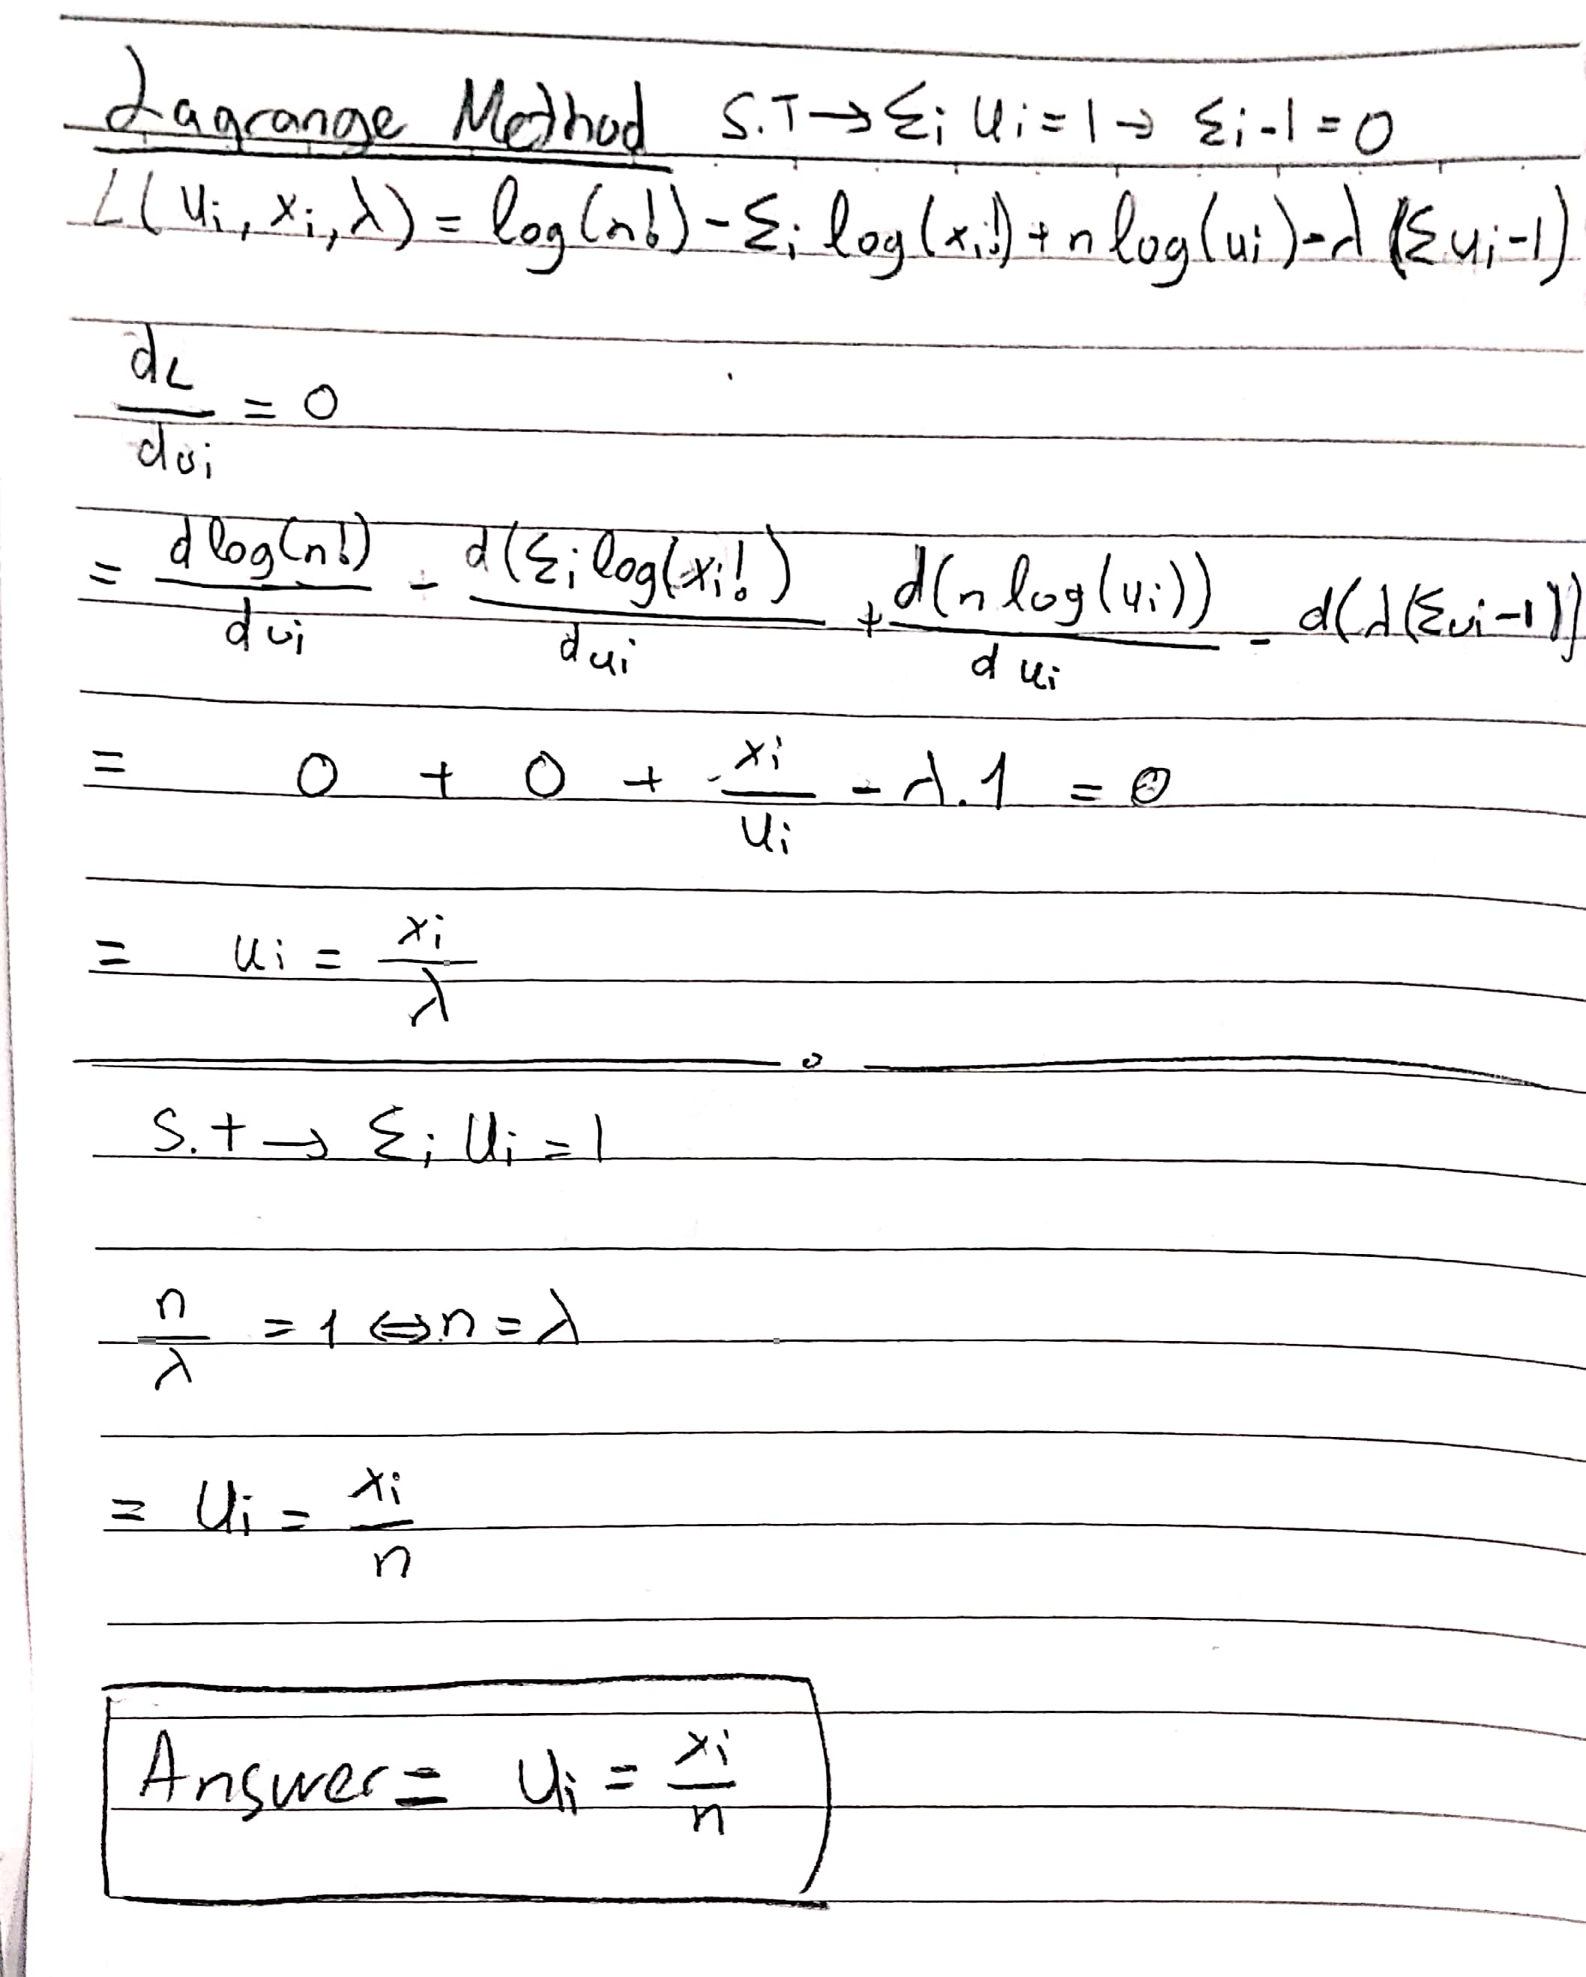



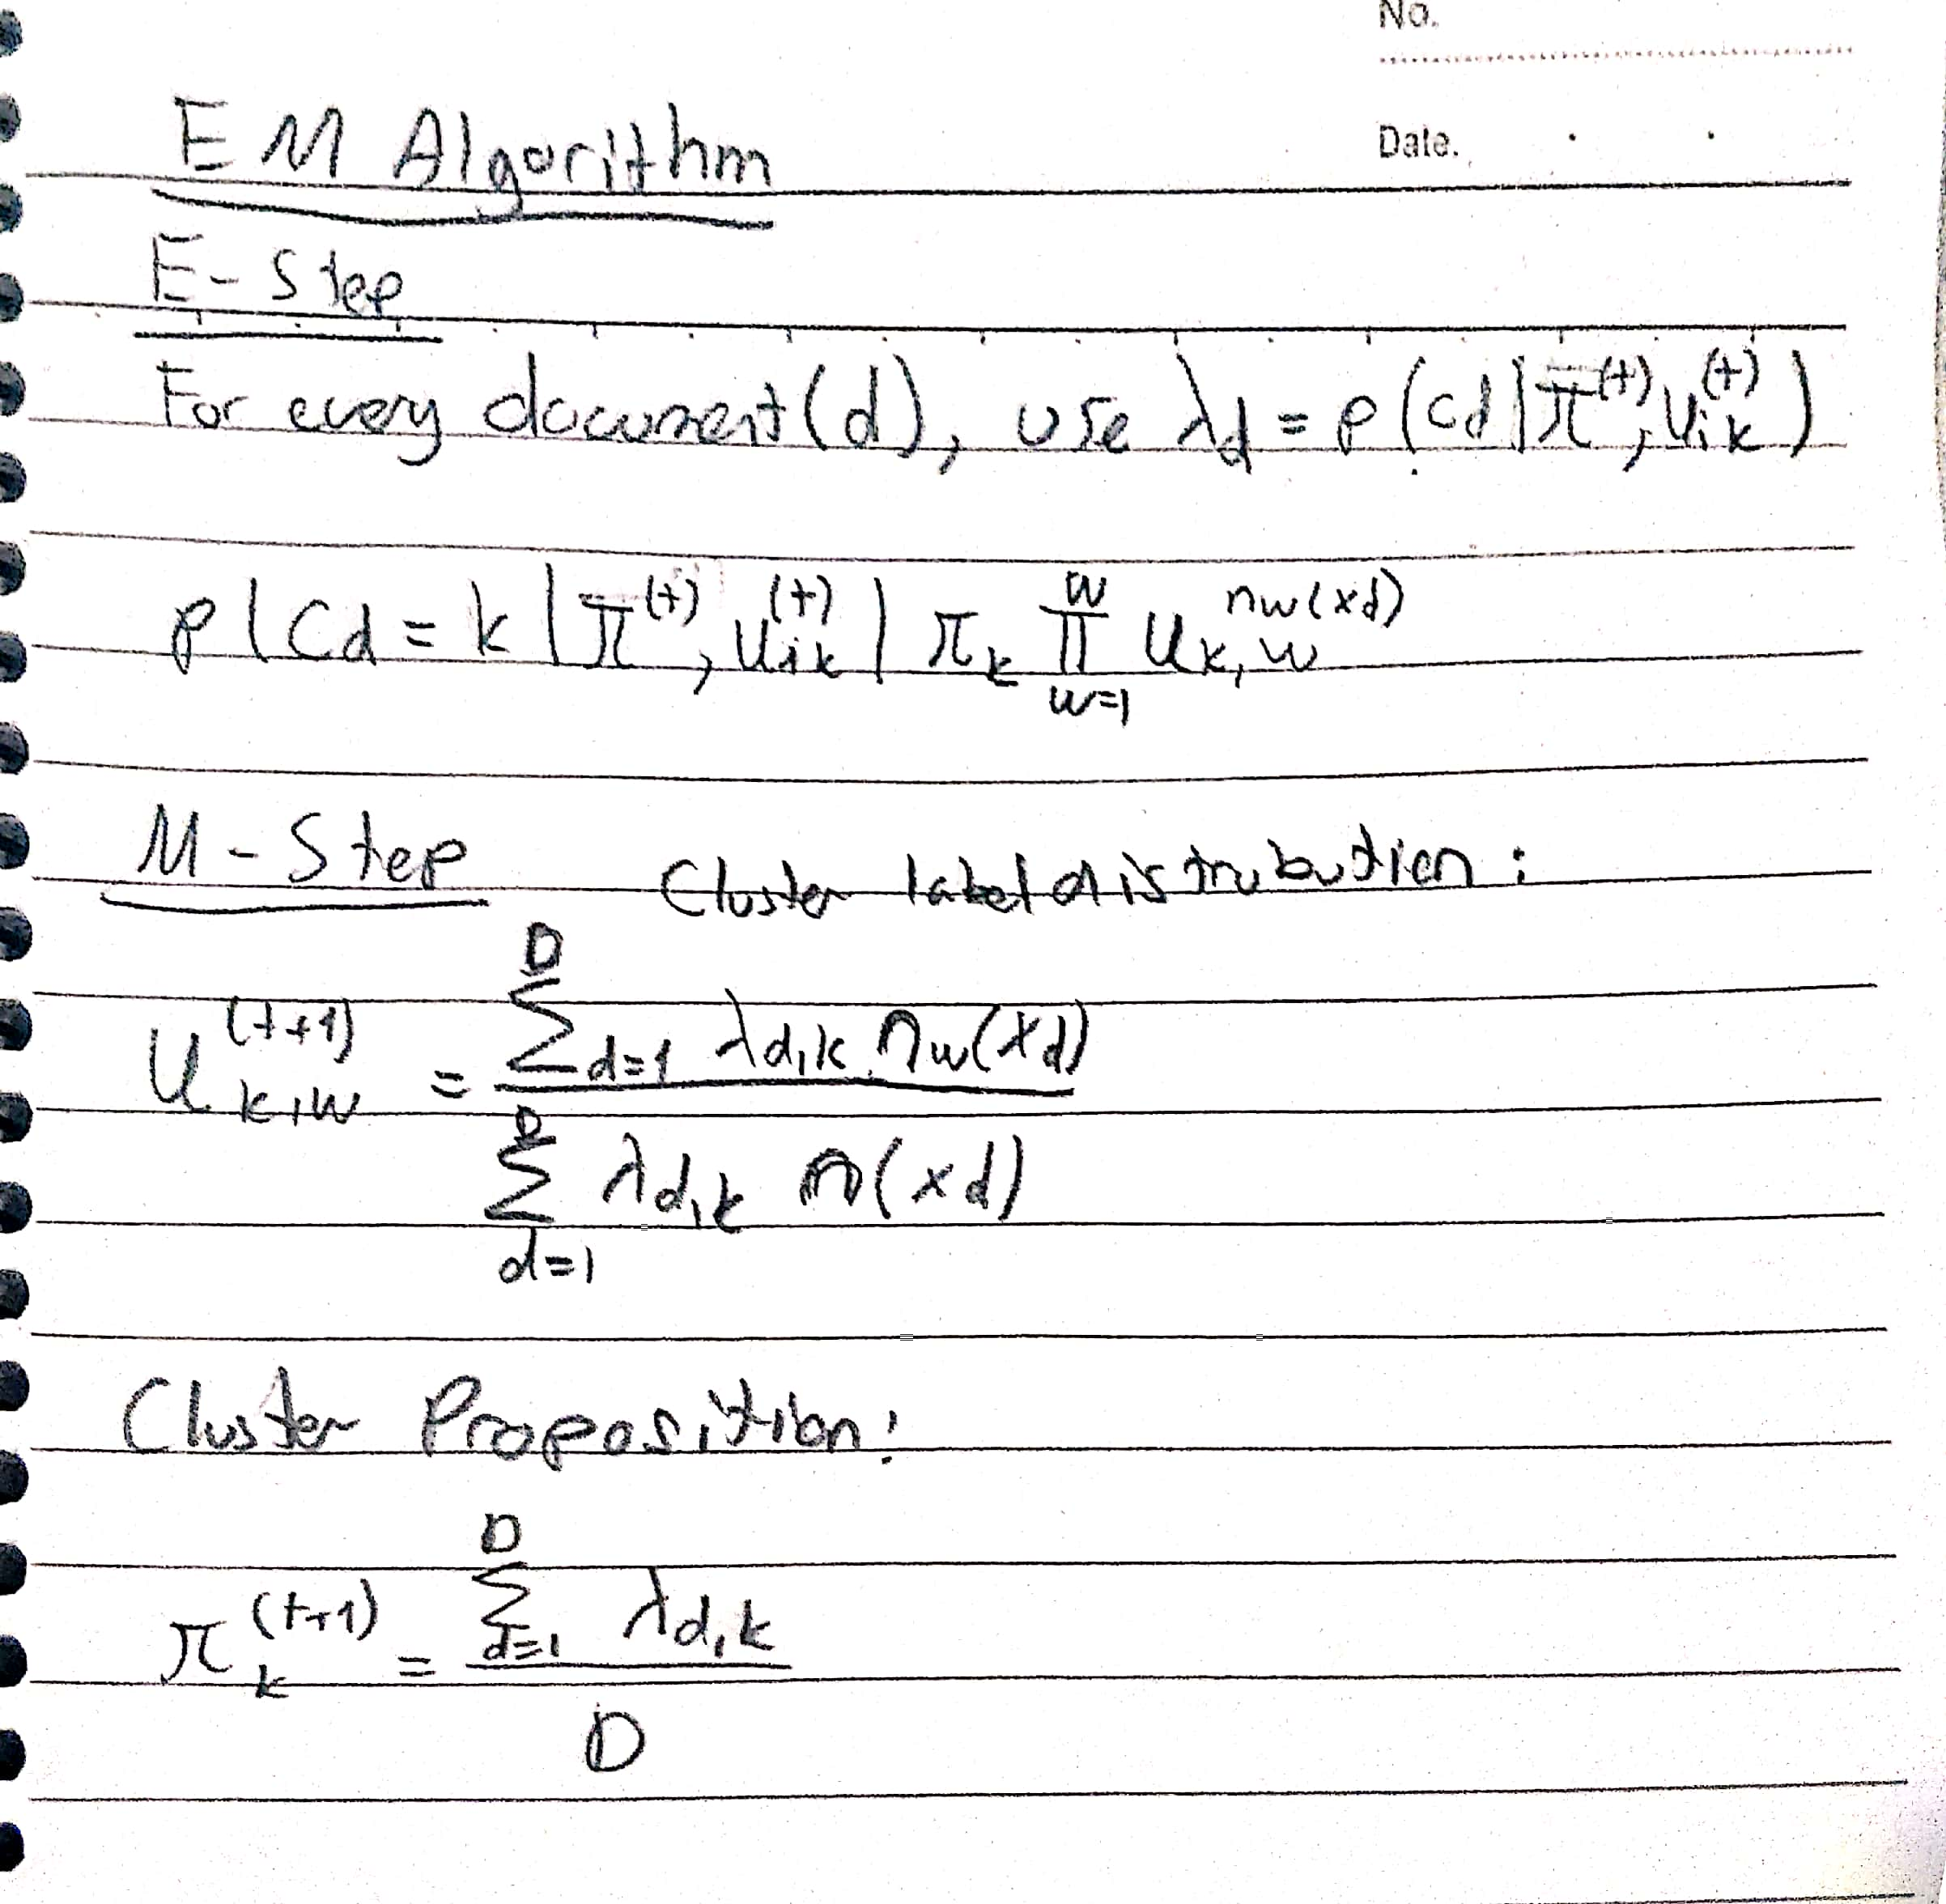

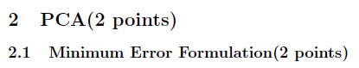

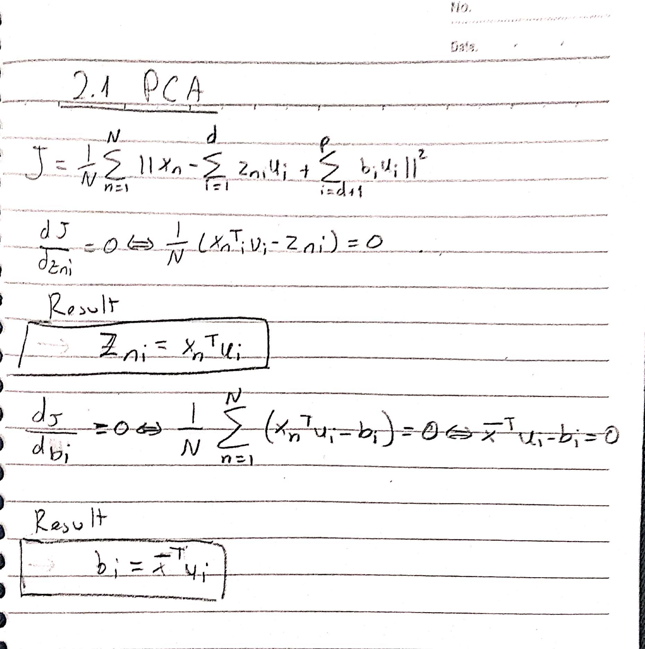

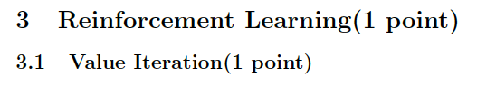

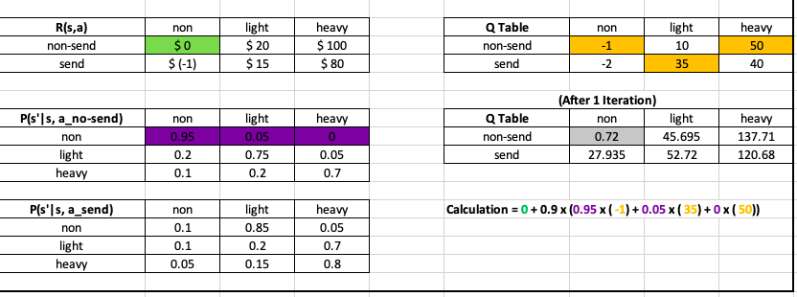

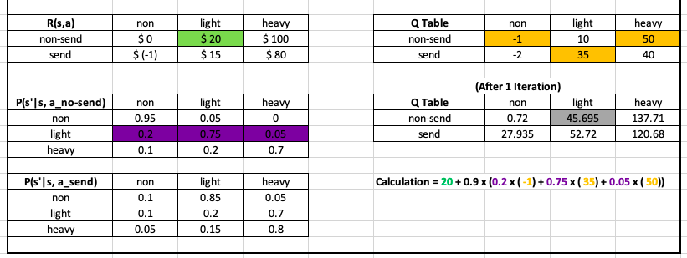

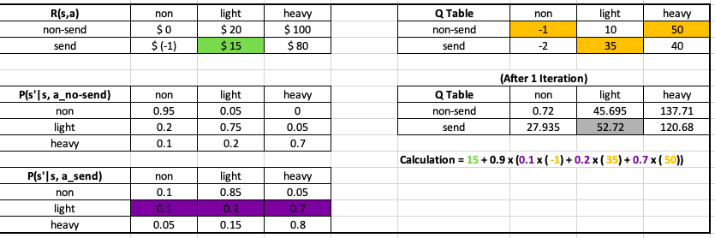

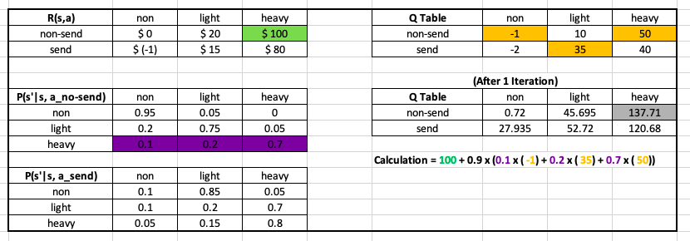

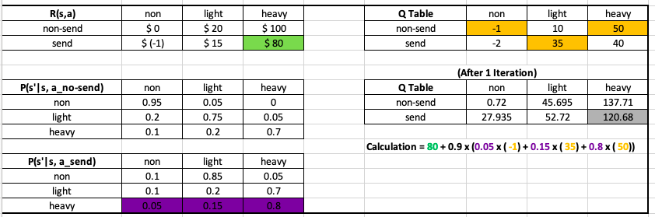

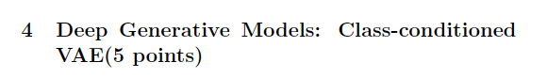

**Findings**

I have found that after comparing 10 and 20 epochs. 20 was clearer on the edges and more understandable.

Here are the comparison photos:

10 20

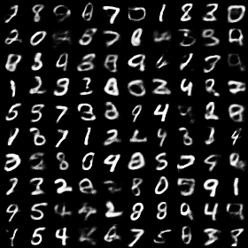 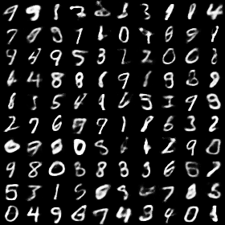

output of test lower bound and Log Likelihood:

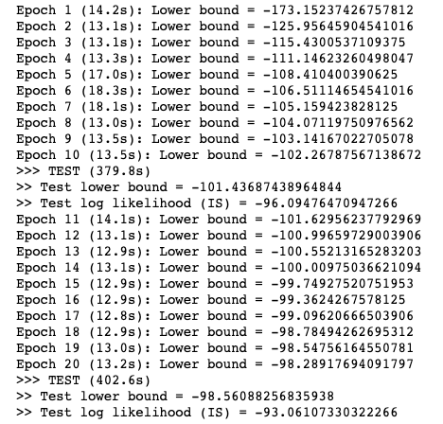

**Appendix Code**

#!/usr/bin/env python

# -*- coding: utf-8 -*-

from __future__ import absolute_import

from __future__ import print_function

from __future__ import division

import os

import time

import tensorflow as tf

from six.moves import range

import numpy as np

import zhusuan as zs

from examples import conf

from examples.utils import dataset, save_image_collections

@zs.meta_bayesian_net(scope="gen", reuse_variables=True)

def build_gen(x_dim, z_dim, n, n_particles=1):

bn = zs.BayesianNet()

z_mean = tf.zeros([n, z_dim])

z = bn.normal("z", z_mean, std=1., group_ndims=1, n_samples=n_particles)

h = tf.layers.dense(z, 500, activation=tf.nn.relu)

h = tf.layers.dense(h, 500, activation=tf.nn.relu)

x_logits = tf.layers.dense(h, x_dim)

bn.deterministic("x_mean", tf.sigmoid(x_logits))

bn.bernoulli("x", x_logits, group_ndims=1)

return bn

@zs.reuse_variables(scope="q_net")

def build_q_net(x, z_dim, n_z_per_x):

bn = zs.BayesianNet()

h = tf.layers.dense(tf.cast(x, tf.float32), 500, activation=tf.nn.relu)

h = tf.layers.dense(h, 500, activation=tf.nn.relu)

z_mean = tf.layers.dense(h, z_dim)

z_logstd = tf.layers.dense(h, z_dim)

bn.normal("z", z_mean, logstd=z_logstd, group_ndims=1, n_samples=n_z_per_x)

return bn

def main():

# Load MNIST

data_path = os.path.join(conf.data_dir, "mnist.pkl.gz")

x_train, t_train, x_valid, t_valid, x_test, t_test = \

dataset.load_mnist_realval(data_path)

x_train = np.vstack([x_train, x_valid])

x_test = np.random.binomial(1, x_test, size=x_test.shape)

x_dim = x_train.shape[1]

# Define model parameters

z_dim = 40

# Build the computation graph

n_particles = tf.placeholder(tf.int32, shape=[], name="n_particles")

x_input = tf.placeholder(tf.float32, shape=[None, x_dim], name="x")

x = tf.cast(tf.less(tf.random_uniform(tf.shape(x_input)), x_input),

tf.int32)

n = tf.placeholder(tf.int32, shape=[], name="n")

model = build_gen(x_dim, z_dim, n, n_particles)

variational = build_q_net(x, z_dim, n_particles)

lower_bound = zs.variational.elbo(

model, {"x": x}, variational=variational, axis=0)

cost = tf.reduce_mean(lower_bound.sgvb())

lower_bound = tf.reduce_mean(lower_bound)

# # Importance sampling estimates of marginal log likelihood

is_log_likelihood = tf.reduce_mean(

zs.is_loglikelihood(model, {"x": x}, proposal=variational, axis=0))

optimizer = tf.train.AdamOptimizer(learning_rate=0.001)

infer_op = optimizer.minimize(cost)

# Random generation

x_gen = tf.reshape(model.observe()["x_mean"], [-1, 28, 28, 1])

# Define training/evaluation parameters

epochs = 20

batch_size = 128

iters = x_train.shape[0] // batch_size

save_freq = 10

test_freq = 10

test_batch_size = 400

test_iters = x_test.shape[0] // test_batch_size

result_path = "results/vae"

# Run the inference

with tf.Session() as sess:

sess.run(tf.global_variables_initializer())

for epoch in range(1, epochs + 1):

time_epoch = -time.time()

np.random.shuffle(x_train)

lbs = []

for t in range(iters):

x_batch = x_train[t * batch_size:(t + 1) * batch_size]

_, lb = sess.run([infer_op, lower_bound],

feed_dict={x_input: x_batch,

n_particles: 1,

n: batch_size})

lbs.append(lb)

time_epoch += time.time()

print("Epoch {} ({:.1f}s): Lower bound = {}".format(

epoch, time_epoch, np.mean(lbs)))

if epoch % test_freq == 0:

time_test = -time.time()

test_lbs, test_lls = [], []

for t in range(test_iters):

test_x_batch = x_test[t * test_batch_size:

(t + 1) * test_batch_size]

test_lb = sess.run(lower_bound,

feed_dict={x: test_x_batch,

n_particles: 1,

n: test_batch_size})

test_ll = sess.run(is_log_likelihood,

feed_dict={x: test_x_batch,

n_particles: 1000,

n: test_batch_size})

test_lbs.append(test_lb)

test_lls.append(test_ll)

time_test += time.time()

print(">>> TEST ({:.1f}s)".format(time_test))

print(">> Test lower bound = {}".format(np.mean(test_lbs)))

print('>> Test log likelihood (IS) = {}'.format(

np.mean(test_lls)))

if epoch % save_freq == 0:

images = sess.run(x_gen, feed_dict={n: 100, n_particles: 1})

name = os.path.join(result_path,

"vae.epoch.{}.png".format(epoch))

save_image_collections(images, name)

if __name__ == "__main__":

main()